**North Wales Dementia Centre branded a “lifeline for families”**

Tuesday, 9 September, 2025

* [Local News](https://www.darrenmillar.wales/news/category/Local-News)

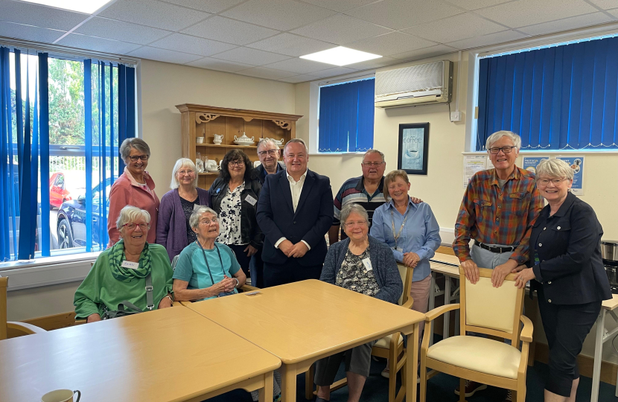

A centre providing vital support for people with dementia and their families has been commended by Welsh Conservative Leader and Clwyd West MS Darren Millar who visited staff, service users and volunteers there last week.  
  
North Wales Dementia Centre, which is based in Mochdre, opened in 2021 and since that time has played an instrumental role in helping thousands of families whose lives have been impacted by dementia.  
  
Darren visited the centre for the first time shortly after it was opened and returned last week for an update on their work.  
He met with Dementia Centre Co-ordinator Tina Lee and other staff and volunteers, and also had the opportunity to speak to those benefitting from the services provided at the centre.  
  
Following his visit, Darren said:  
  
“The North Wales Dementia Centre is a much-needed facility here in North Wales and I very much welcomed its opening back in 2021.  
  
“ I was very pleased to return last week for a catch up with Tina and the team and to find out more about the vital services they are providing.  
  
“During my visit, as well as talking to staff and volunteers, I spent time with families benefitting from the services provided at the centre.  Issues raised with me included, GPs not undertaking periodic dementia reviews, A&E waiting times, and a lack of proper understanding about dementia in our hospitals. All these issues are adding to the stress families living with dementia are already facing and need to be addressed.”     
  
Darren added:  
  
“Often following a dementia diagnosis, families feel overwhelmed, isolated and unsure where to turn. This fantastic centre empowers people with dementia and their loved ones with the support and tools they need to navigate this challenging journey.  
  
“It is more than just a building, it’s a lifeline for families and I can’t thank Tina and the rest of the team enough for the wonderful work they are doing.”  
  
The Dementia Centres in North Wales offer: information and advice; training and education; social history sessions; adapting to behavioural changes sessions; future planning sessions; guest speakers; emotional support; health clinics; long term support via peer support clubs; and keep in touch calls.  
  
You can attend group information sessions if you are living with dementia or are an unpaid carer. One-to-one sessions are also available if you do not feel ready to attend a group session and telephone sessions are available to everyone.  
  
The North Wales Dementia Centre services are available to anyone who lives in North Wales. Anyone in need of information, advice or support can call 01492 542212. The centre is based at the Quinton Hazell Enterprise Parc, Glan y Wern Road, Mochdre, Colwyn Bay, LL28 5BS.